**ASSIGNMENT – 1**

**Kaustubh Naithani**



**Basic Linux Commands Assignments**

**Assignment-1**

Connect and disconnect with login Access

* What happens when you login a non-existent users or username?
  + Provide Screenshot and What you understand, explain in short brief?

**Answer ->**

When we enter a non-existent user or username the os tells us to recheck the username and password that we have given.

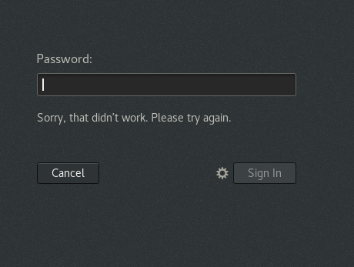

**Assignment-2**

Password changing

* Login into your account and then change password?
  + Change your password into **IneuR0n#42** and hit the **Enter** key
    - Explain what happen and give screenshot?

**Answer ->**

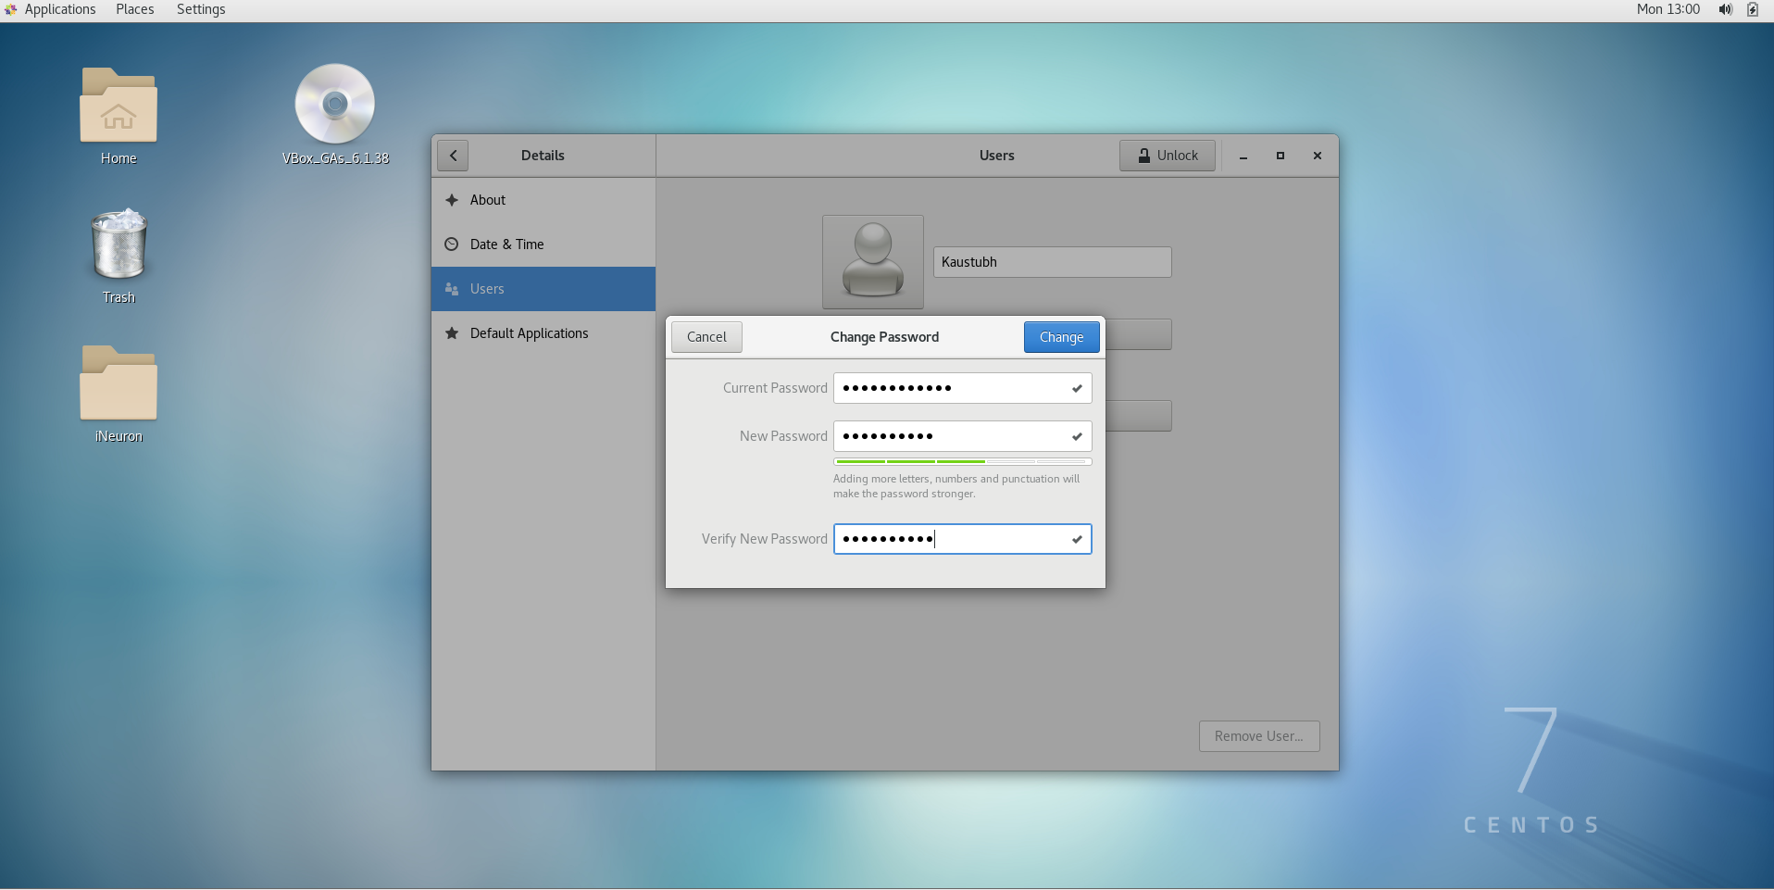

After changing the password, the password is successfully changed.

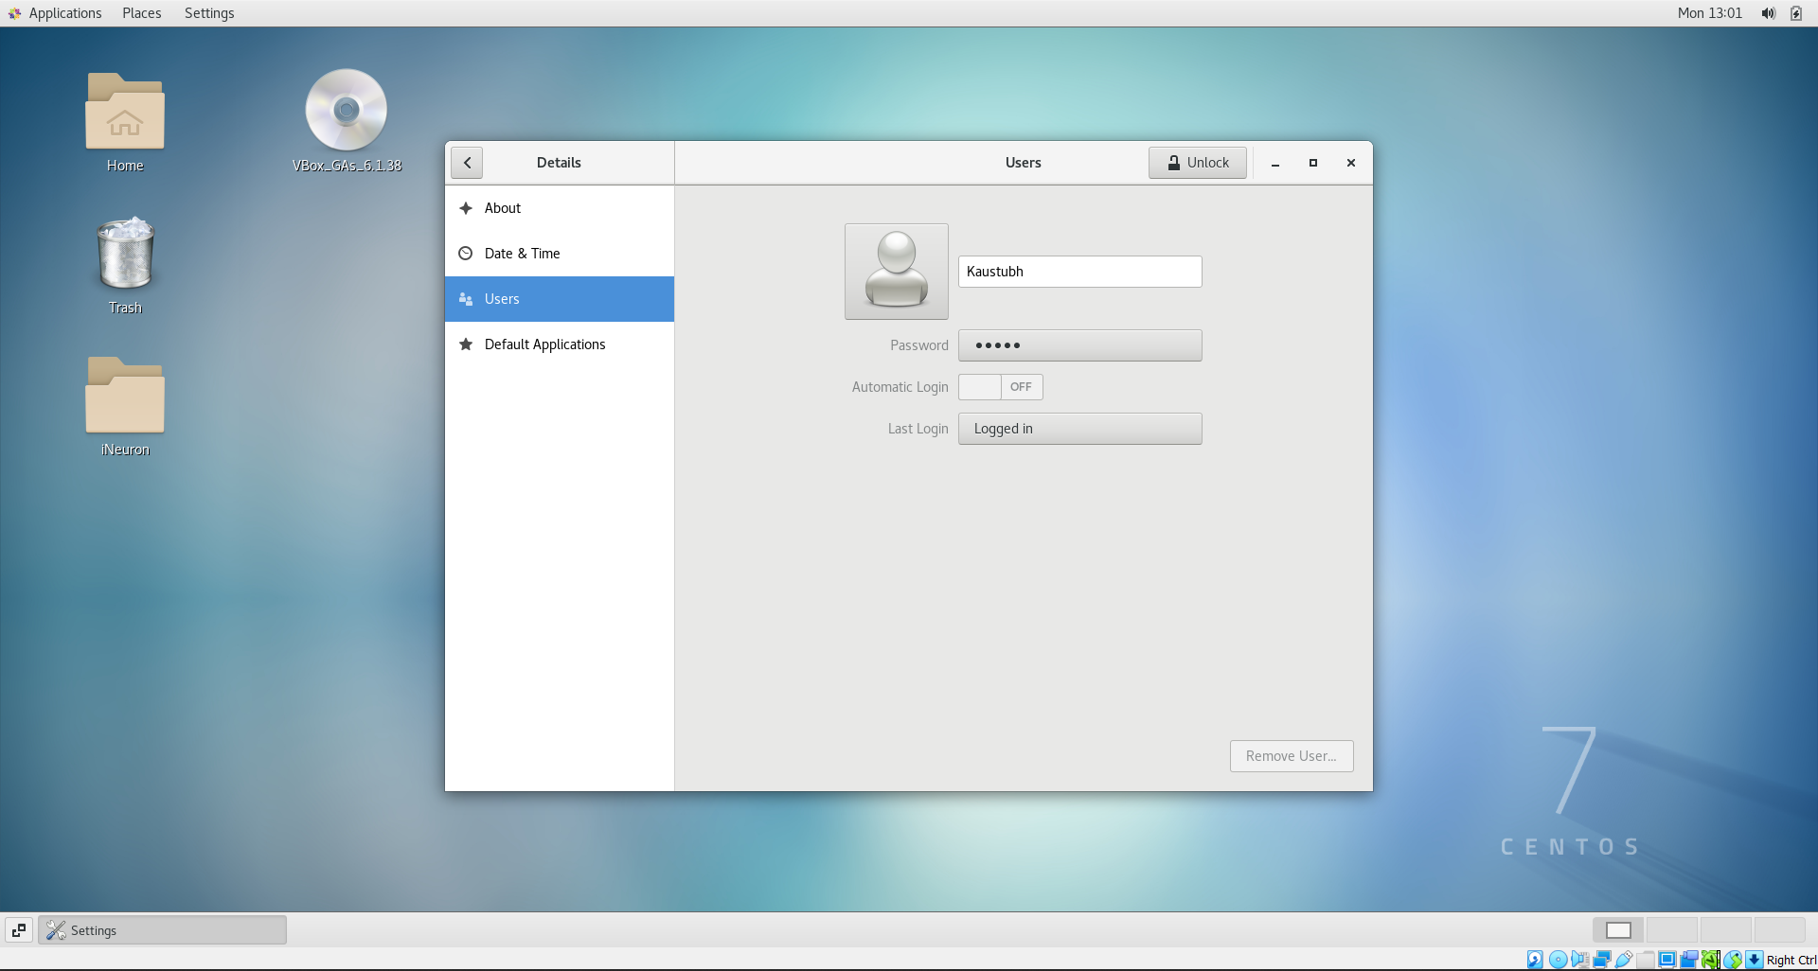

* + Try again to change password but use like password ***1234*** or ***abcd***
    - Explain what happen and give screenshot?

**Answer ->**

If I change my password to 1234 or abcd it will show that the password is too short and weak.

And as a result I can not change my password as I have to make it more lengthy and secure.

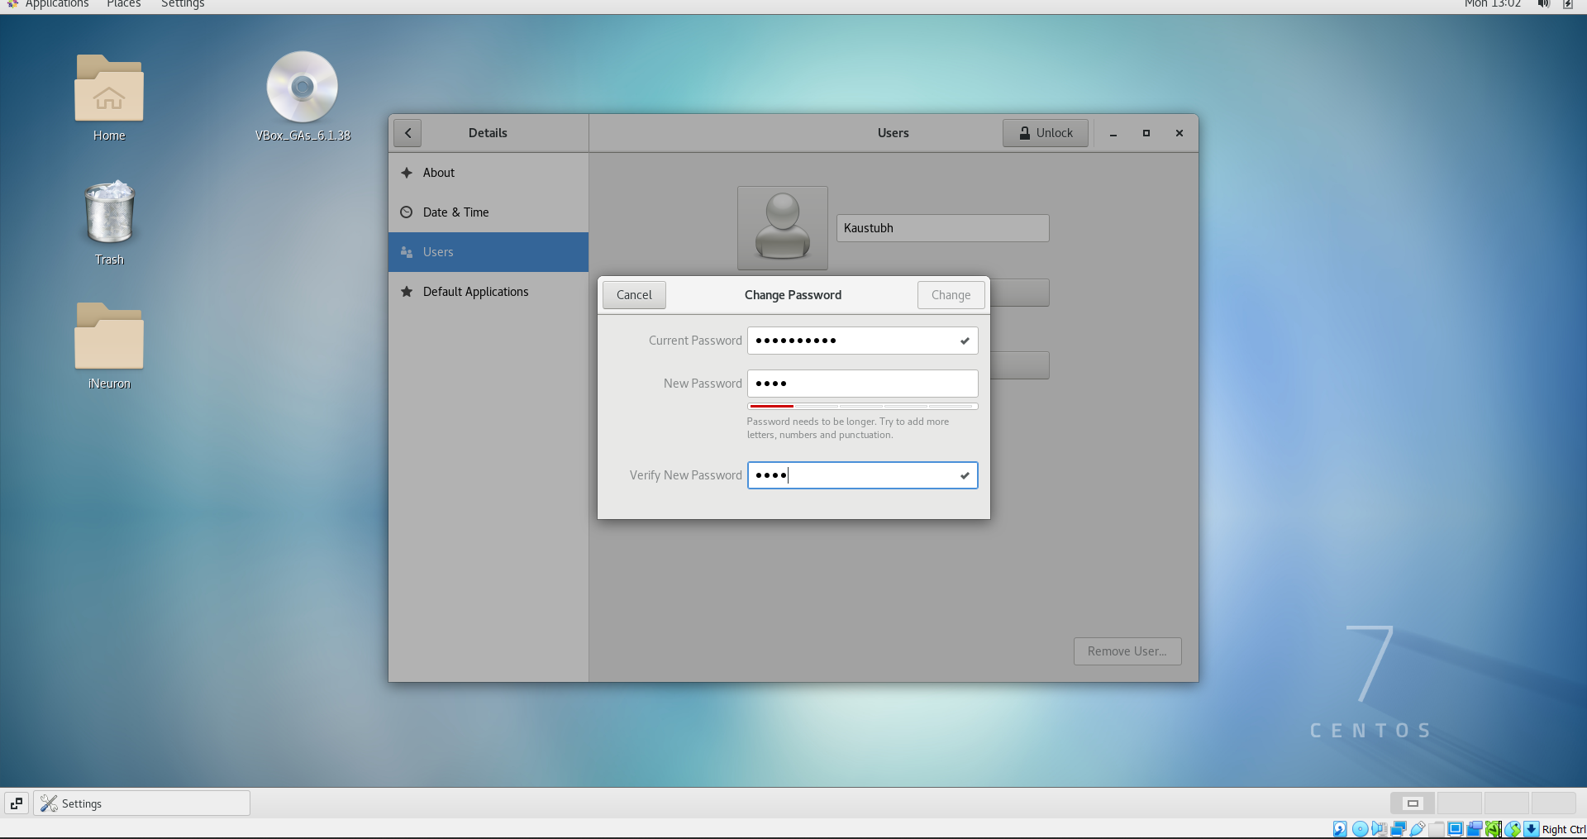

* + Try again to change password but now don’t use any password just hit **Enter** key
    - Explain what happen and give screenshot?

**Answer ->**

If I hit enter without using any new password it will not register my commands as I have to put a new password in order to continue.

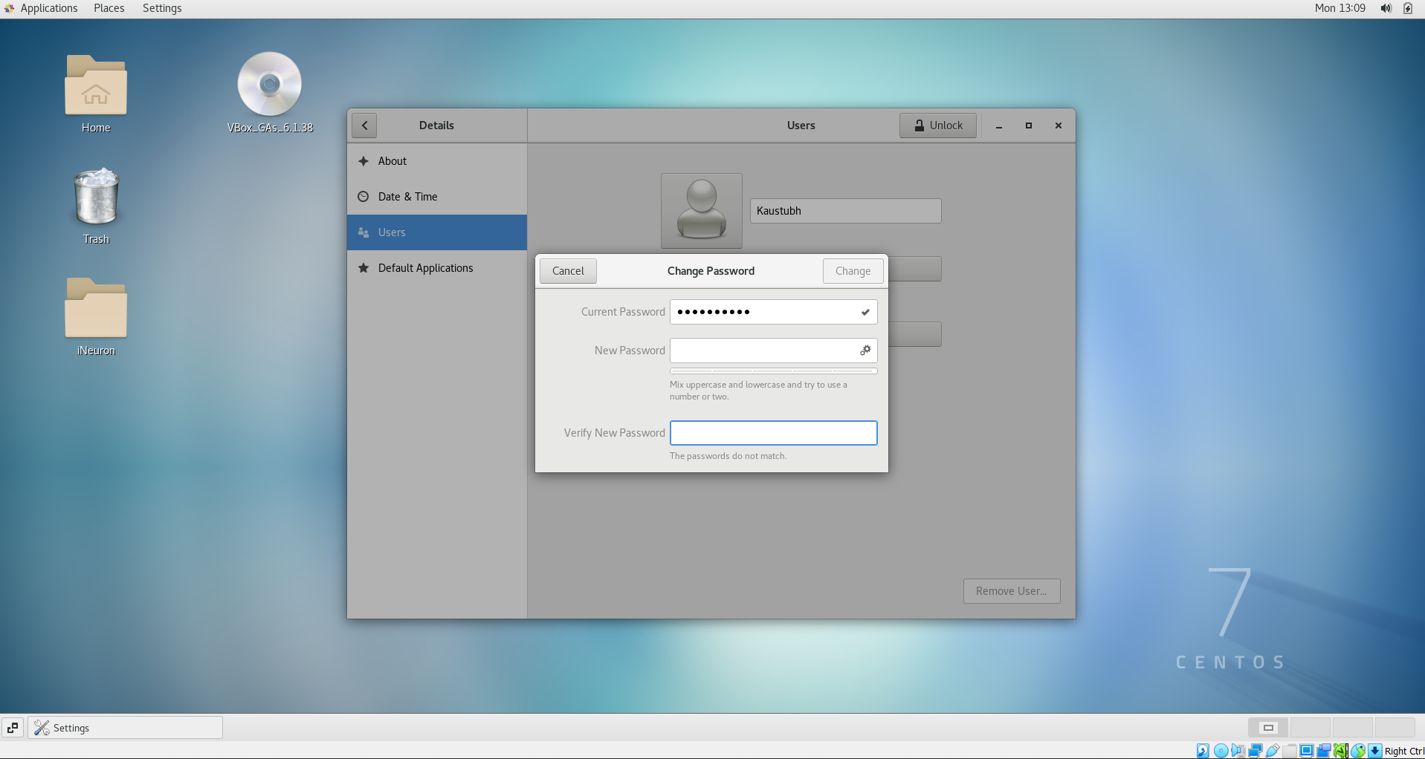

**Assignment-3**

Working with Directories

* Enter the command **cd /** and then **ls** and then hit **Enter** key
  + Take screenshot and explain what output we got?

**Answer ->**

When we enter cd / in the terminal we are taken to the root directory.

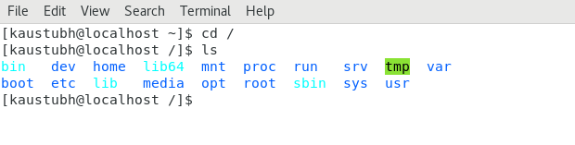

* Enter the command now **cd /home** and then hit **Enter** key
  + Do **ls,** provide screenshot and explain what is **/home** directory used for?

**Answer ->**

Cd /home takes us to home directory inside the root directory. Here files for a given member of the system are displayed.

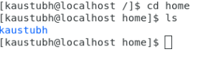

* Enter **cd ..** and hit **Enter** key [ *Note: here we have space after cd then use double dot*]
  + Check what happen and give screenshot?

**Answer ->**

By using cd .. we are taken back to the previous directory.

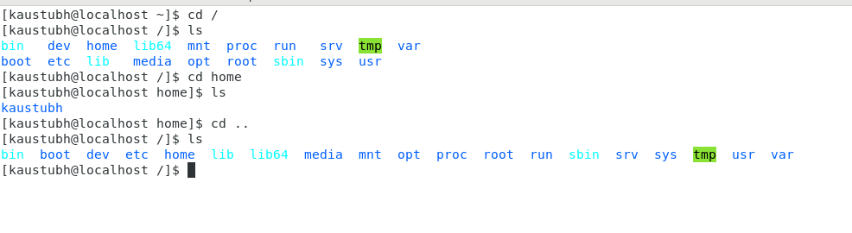

* Now enter **cd /var/www/html** and then type **cd** and hit **Enter** key
  + Explain what happen and give screenshot?

**Answer ->**

Using cd/var/www/html, the terminal shows that there is no such directory present.

And when we enter the cd command again, we are taken back to the home directory.

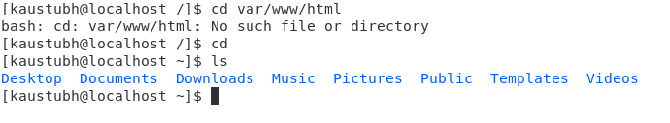

* Now type **cd /root** and then hit **Enter** key
  + Do **ls,** check any output we have on screen if yes then take screenshot?

**Answer ->**

When we do cd /root, we are shown an error that permission denied.



**Assignment-4**

Working with File Listing

* Go to **cd /etc** and type **ls**
  + Take screenshot and explain what files you have seeing?
  + Take screenshot and explain what different output you found compare to previous command you used?

**Answer ->**

We see the files inside the etc folder.

The /etc (et-see) directory is where a Linux system's configuration files live.

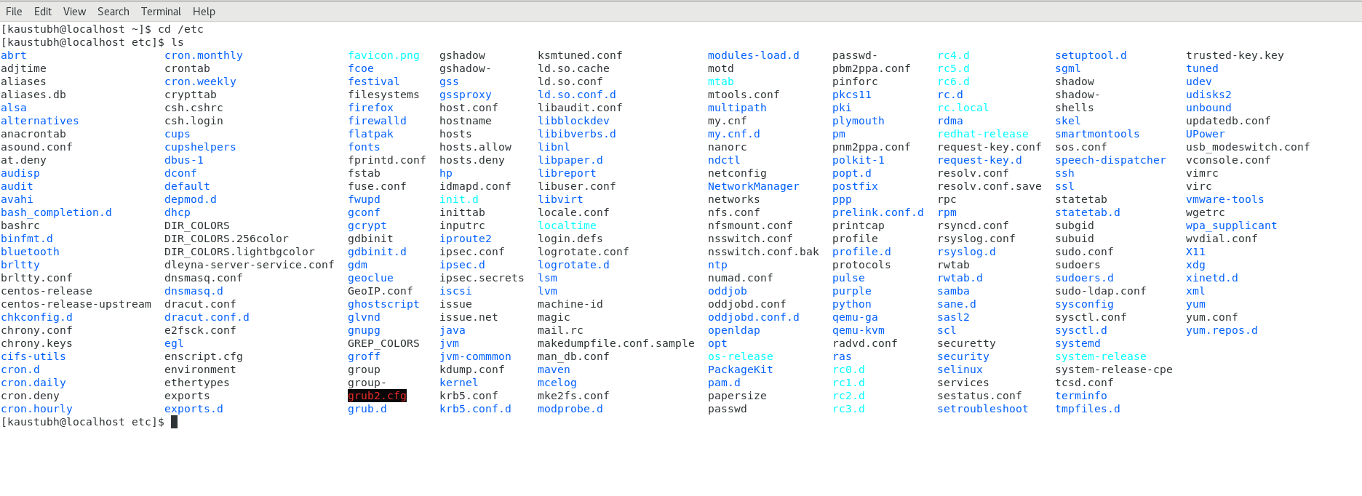

* Then type **ls -al** and hit **Enter** key
  + Take screenshot and explain what new file or directory you found?

**Answer ->**

It gives us a detailed info of each sub directory such as their permissions, the day they are created etc.

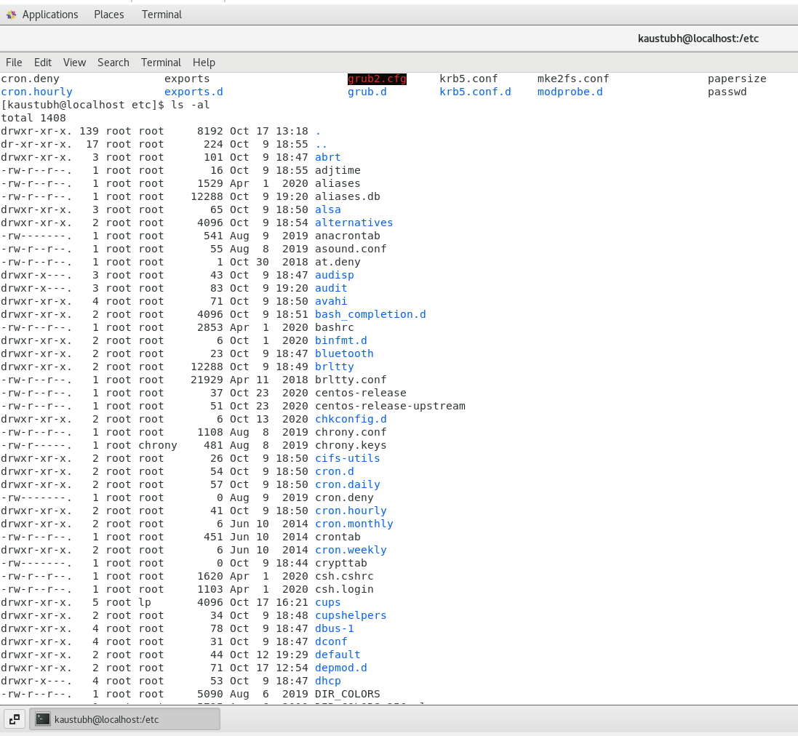

* Then use **ls -i** and hit **Enter** key
  + Now see what different output its shows and take screenshot?

**Answer ->**

list file's inode index number.

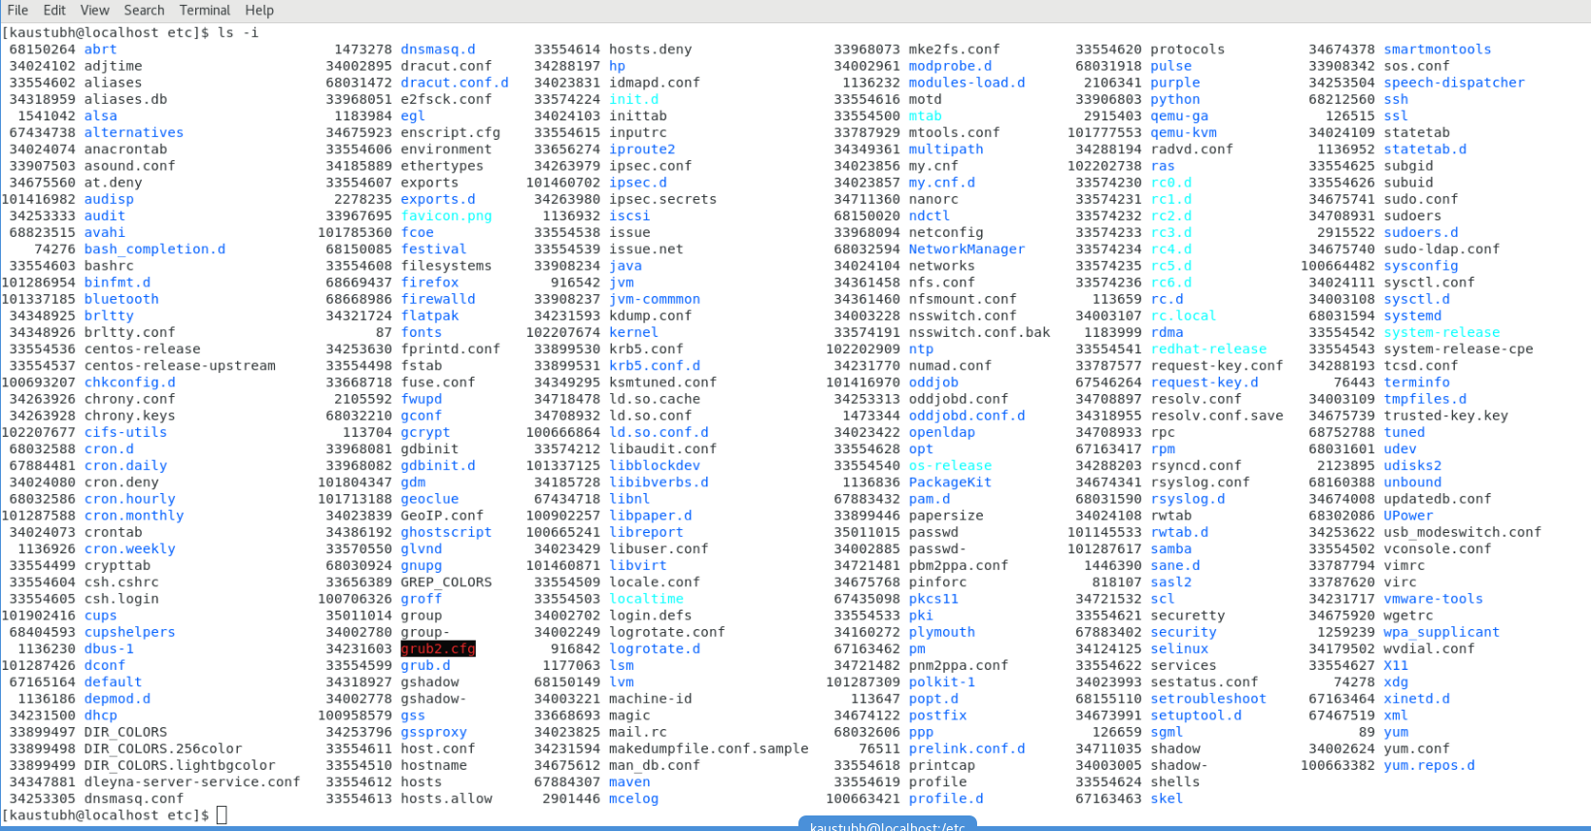

* Then use **ls –help** and see other options about **ls** command
  + Explore it and try with other attribute we can use with **ls** command

**Answer ->**

Ls -x : it alphabetically arranges the files in a directory

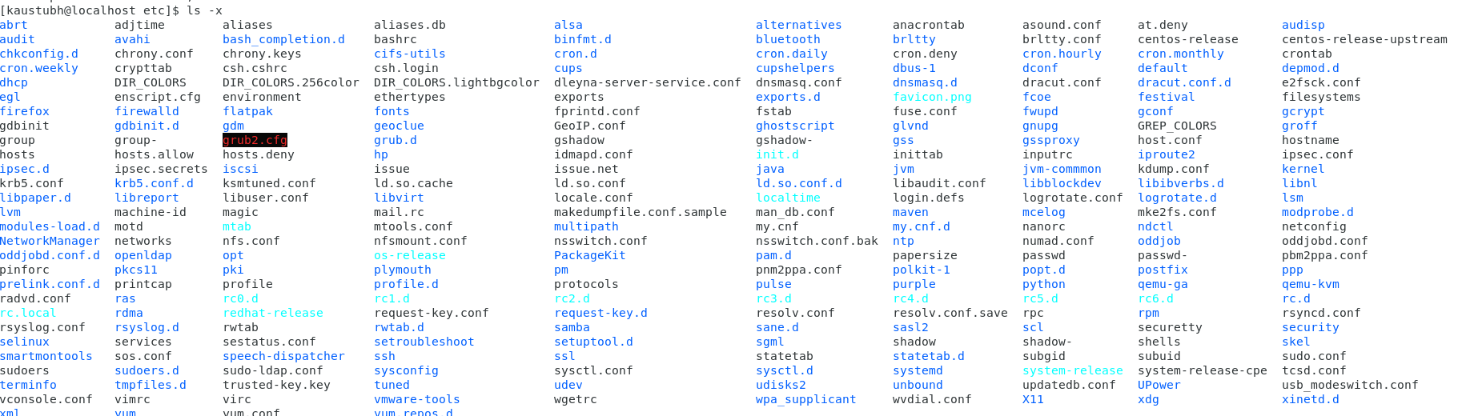

**Assignment-5**

Know where you are and where you working

*Here we use* ***pwd, cd and ls*** *as combine task to understand where you working on terminal and how you can switch from one directory to another one.*

* Open terminal after restart the linux
  + Check which location you working, type **pwd** and take screenshot

Answer ->

Pwd command prints the present working directory.

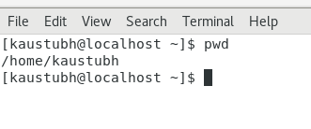

Here the pwd is Kaustubh directory.

* Now use **cd /var** and hit **Enter** key
  + Do **ls,** and see what output comes, give screenshot?

Answer ->

